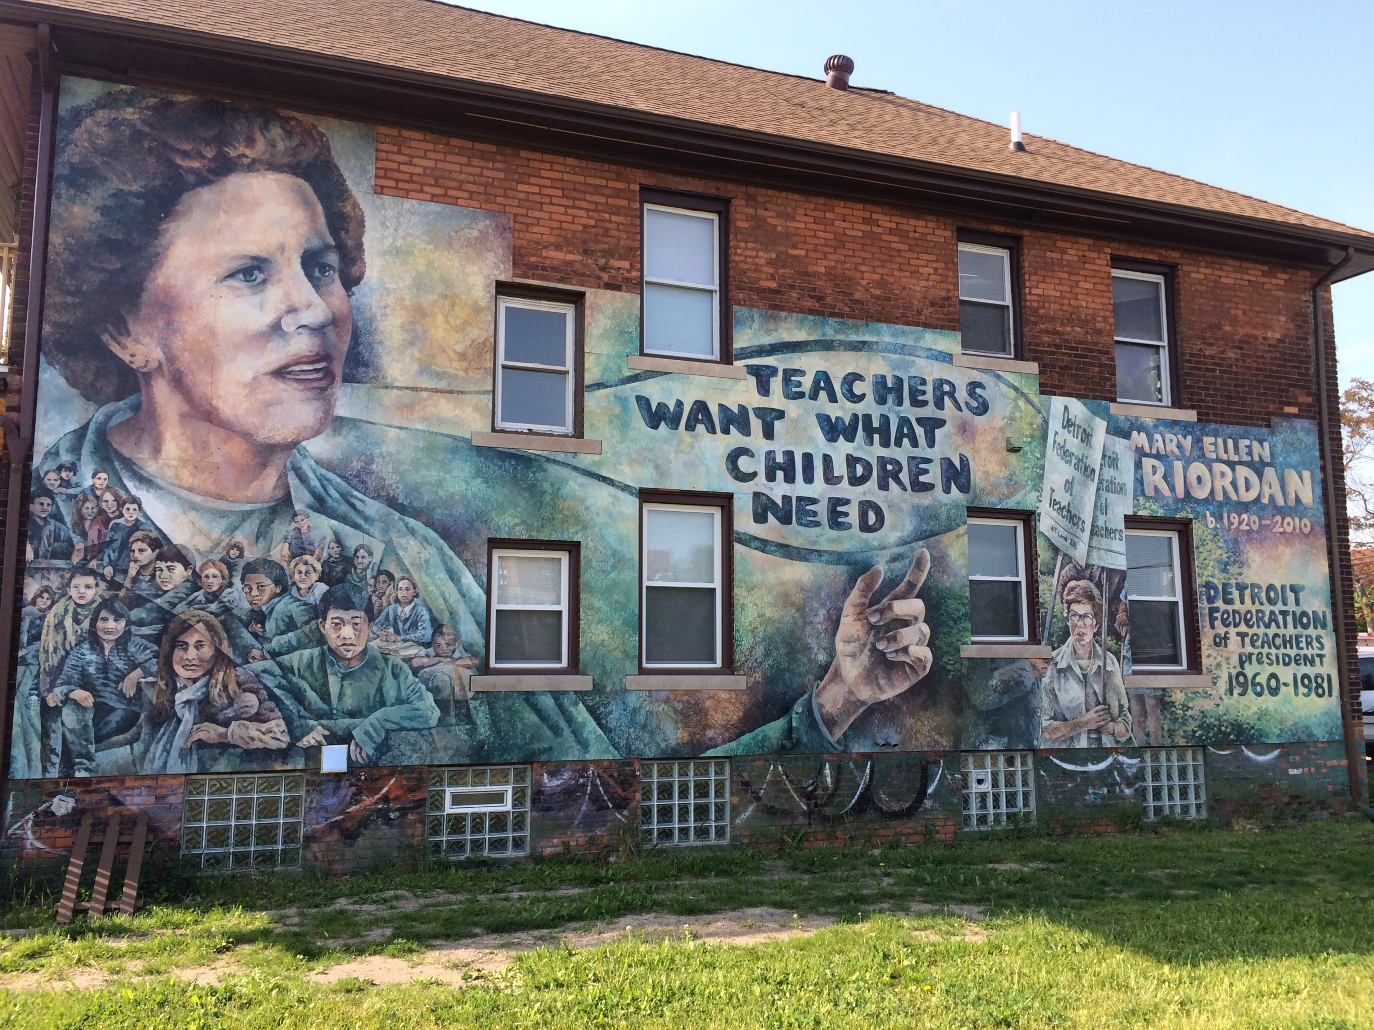
Photo by Jon Zemke

Advanced Methods
Program in Social Studies Education
Spring 2017-Revised

Professor Erika M. Kitzmiller
emk2208@tc.columbia.edu
@erika.kitzmiller
Office Hours: Mondays, 3 – 5 pm
or by appointment, Zankel 420a
Course Location: Grace Dodge Hall 535

Requirements

Attendance and engagement in class discussion
If extenuating circumstances make it necessary for you to miss a class, arrive late or
leave early, you must contact the instructor ahead of time so that the class can be organized accordingly. Unexcused absences will affect your class participation grade.

Your class participation is one component of your final grade in this course; your participation will be evaluated on your ability to integrate concepts from the readings into class discussion through comments and questions as well as the relevance of your remarks to the topic. You are encouraged to bring different perspectives and positions to the discussion, based on your own knowledge and experience. Disagreement and critique of the readings are encouraged, as they can be instructive.

Peer collaboration, feedback, confidentiality and support
The content and structure of this course may facilitate dialogue about our ideologies
with respect to urban spaces, inequality, and justice, as well as about our questions and anxieties with respect to writing and research.

It is crucial that we all take responsibility for creating a safe environment in which open and respectful dialogue can occur.

By safe environment we do not mean that we should not actively challenge one another on important issues because this can be a powerful learning tool. Rather, we mean that this course must be a place in which everyone can discuss differing beliefs and
questions without concern about being judged or having confidential information shared outside of the group. It also means that there will be space and time for people to share perspectives.

For this to happen, we will each need to work hard to remain respectfully tentative about others’ opinions and questions (and critically self-reflective on our own) realizing that we all come with various areas of expertise and have unique perspectives on the world.

Moreover, we need to cognizant of how much we have talked during class. No one should dominate classroom discussions. This kind of participation is a central requirement of this class.

Completion of all assignments by the due date
Late assignments will receive one grade reduction for each day that it is late (unless the instructor granted an extension in writing). Extensions are only granted for serious personal emergencies. So, an A quality paper that is one day late, it will be an A-.

Exams/Assignments
Assignment | Due Date | Percentage of  Final Grade
Institution-Lecture-Activist Reflection | Before April 30th | 20%
Reflection Papers and Lesson Plans (2 over the semester) | 1 Paper Due by March 9th  2 Lesson Plans-One by March 6th; the other by May 6th | 20%
Inquiry Paper |  | 40%
Class Participation |  | 20%

Institution-Lecture-Activist Reflection
Choose an event related to education or teaching in the New York City area. After you attend the community event, you write a reaction (no more than 1200 words) that includes a very short (no more than 100 words) summary of the event and describes your reaction to the event and its connection to the concepts that we have covered in class. You should cite course readings, when possible. I also encourage you to share your experiences where relevant during class discussion. If you have a suggestion for an event not included in the provided list that you would like to attend, please email me your request at least a week prior to the date.
Reflection Papers
Students should submit one 1-2 page response paper in response to the readings and questions on the syllabus over the course of the semester. It should be submitted at least 24 hours before class. This is due by March 9th. You should submit two lesson plans and illustrate how they incorporate the needs of immigrant youth, Black youth, LBGTQ youth, etc. The first is due on March 6th and must incorporate materials from the NY Historical Society. The second is due by May 6th.

Teacher Inquiry Project
Over the course of the semester, you will keep a journal documenting your practice and your ideas/questions/reflections about your inquiry project. At the end of the semester, you will use the field notes and reflections to write a 12 – 15 page paper (or some other medium of your choice) that integrates your practice with the course materials.

Statement on Academic Honesty
In this class, we will be analyzing the thoughts, arguments, and evidence of others. This work will be critical in helping you develop your own ideas and arguments. Plagiarism occurs when you present someone's ideas, arguments, or evidence as your own and without attribution or acknowledgment. Plagiarism occurs in (but is not limited to) the following instances, copying or paraphrasing someone's writing without acknowledgment; using someone's facts or ideas without acknowledgment; submitting someone's work, or work that you have submitted for another course. Plagiarizing undermines the very foundation of our academic community and thus cannot and will not be tolerated. The issue of academic integrity is taken very seriously. If you have any questions about any aspect of doing honest academic work, please don’t hesitate to ask. No question is too minor. Any student found cheating will face the disciplinary rules of her or his home college and a zero on the assignment.

All work that you submit for this class must be your own. Building on the ideas of others is a critical part of academic work, but you MUST clearly credit the people whose ideas and/or words and/or images you are using EVERY time you use them. You must not present the work of another as your own by copying or paraphrasing their words, ideas and/or images without properly citing them. You must include the author and date of publication you are referencing in your text and have complete bibliographic information at the end of the paper, otherwise you are plagiarizing- you are stealing. We can discuss how to cite sources properly in class, and you are encouraged to see me if you have any questions. The Chicago Manual of Style is accessible on the internet for reference (http://www.chicagomanualofstyle.org/tools_citationguide.html), and the Author Date method of in-text parenthetical citations is preferred. You may also use another recognized social science format with which you are familiar, just be consistent and cite all of your sources whenever you use them with the author, date of publication, and the page number, if applicable.

Students with Disabilities
Students who need special accommodations due to disabilities are encouraged to meet with me as soon as possible, and registering with the Office of Disability is strongly encouraged. I am here to be supportive, but can only help if you ask!

Laptop Policy
I will allow computers in class as long as students only use them for taking notes, or for retrieval/referral to on-line class readings. This policy is subject to change if the instructor believes that the guidelines about usage are not being followed. That is, if I believe that computers are being used for non-instructional purposes, then computers will no longer be allowed in class. The only students who will be able to use computers will be those students who can provide documentation that they need it as part of their learning accommodation. If your fellow student is not adhering to this guideline and it is proving to be a distraction for you, please do not hesitate to contact me.

Course Texts and Materials
Elbow, Peter. Writing Without Teachers, 2nd edition. Oxford: Oxford University Press, 1998.
Kirkland, David. A Search Past Silence: The Literacy of Young Black Men. New York: Teachers College
Press, 2013
Winn, Maisha. Girl Times: Literacy, Justice, and School-to-Prison Pipeline. New York: Teachers College
Press, 2011
All other readings are on the class google drive.

Class Sessions

Week 1: Course Introduction (January 23rd)
The View from Room 205: http://interactive.wbez.org/room205/

Week 2: Teacher Inquiry-Teacher Researcher—Taking a Stance on Our Practice
What is Teacher Inquiry? How could it be helpful to our understanding of practice? What are its risks?
(January 30th)
Cochran-Smith, Marilyn and Susan Lytle, “Research on Teaching and Teacher Research: The Issues
that Divide,” Educational Researcher, March 1990, Read pages 7- 11.
Strieb, Lynn Yermanock. “Visiting and Revisiting the Trees,” Chapter 6 in Cochran-Smith, Marilyn
and Susan Lytle, Inside/Outside; Teacher Research and Knowledge, pp. 121-130.
Feldgus, Eileen Glickman, “Classroom and School Studies,” Chapter 8 in Cochran-Smith, Marilyn
and Susan Lytle, Inside/Outside; Teacher Research and Knowledge, pp. 170 – 177.
Brown, Shirley P. “Lighting Fires,” Chapter 9 in Cochran-Smith, Marilyn
and Susan Lytle, Inside/Outside; Teacher Research and Knowledge, pp. 241-249.

Week 3: Teacher as Writer, Teacher as Activist (February 6th)
Visit from Jose Vilson, author of This is Not a Test.
Please read all or part of the book and be prepared to ask him about his experiences attending, working, and writing about New York City schools.

Week 4: Motivation and Engagement (February 13th)
Headden, Susan and Sarach McKay, Motivation Matters: How New Research Can Help Teachers Boost
Student Engagement. Carnegie Foundation for the Advancement of Teaching, July 2015. [feel free to skim, if the research gets annoying]
Washor, Elliot and Charles Mojkowski, “Student Disengagement: It’s Deeper than You Think,” Phi
Delta Kappan, May 2014, p. 8 -10.
Hanford, Emily, “Angela Duckworth and the Research on ‘Grit,’” American Radioworks,
http://americanradioworks.publicradio.org/features/tomorrows-college/grit/angela-duckworth-grit.html
Ted Talk, Angie Duckworth, Grit, https://www.ted.com/talks/angela_lee_duckworth_grit_the_power_of_passion_and_perseverance
Kundu, Anindya, “Grit, overemphasized: agency overlooked,” Phi Delta Kappan, September 2014, p.
80.
Optional: Podcast: http://www.npr.org/2016/04/04/472162167/the-power-and-problem-of-grit
In Class: the Grit test, http://angeladuckworth.com/grit-scale/

Week 5: Discussion Based Learning—Talking, Listening, Silencing (February 20th)
Fine, Michelle, “Silencing and Nurturing Voice in an Improbably Context: Urban Adolescents in
Public School,” in Fine, Michelle and Lois Weiss, Extraordinary Conversations and Silenced Voices, New York: Teachers College Press, 2003, p. 13-37
Kohn, Alfie. “The Classroom as Community,” Chapter 7 in Beyond Discipline: From Compliance to
Community, Alexandria: ASCD, 1996, p. 101-119.
Kraft, Matthew A., “From Ringmaster to Conductor,” Phi Delta Kappan, April 2010, p. 44 – 47.
Cain, Susan, “Help Shy Kids, Don’t Punish Them,” Atlantic Monthly, February 12, 2013.

Week 6: Visit to the New York Historical Society (February 27th)

Week 7: Assessment and Feedback (February 27th)
Kohn, Alfie. “The Trouble with Rubrics,” English Journal, Vol. 95, No. 4, March 2006.
Kohn, Alfie. “Rethinking Homework,” Blog Post.
Elbow, Peter. Writing Without Teachers, 2nd edition. Oxford: Oxford University Press, 1998
[selections tbd]
Workshop: Bring in test or assessment that you have used or plan to use in your classroom.
Lesson Example for Class:
http://www.smithsonianeducation.org/educators/lesson_plans/collect/crecla/crecla0a.htm
https://beyondthebubble.stanford.edu/chronological-list-hats

Week 8: Social Studies: A place for reading and writing (March 6th)
Kirkland, David. A Search Past Silence: The Literacy of Young Black Men. New York: Teachers College
Press, 2013 [Selections]

March 12th – March 19th Spring Break

Week 9: Race in the Classroom (March 20th)
Tateishi, C. (2008). Taking a chance with words: Why are the Asian American kids silent in the
class? Rethinking Schools, 42(2).
Watson, D. (2011). What do you mean when you say urban? Speaking honestly about race and
students. Rethinking Schools, 26(1), pp. 48-50.
Santiago, Maribel. “Teaching a New Chapter of History,” Phi Delta Kappan, March 2013, p. 35 – 38.

Week 10: Gender in the Classroom (March 27th)
Thomas, D.E., & Stevenson, H. (2009). Gender risks and education: The particular classroom
challenges for urban low-income African American boys. Review of Research in Education, 33,160-180.
Winn, Maisha. Girl Times: Literacy, Justice, and School-to-Prison Pipeline. New York: Teachers College
Press, 2011 [Selections].

Week 11: Disabilities in the Classroom (April 3rd)
Kliewer, C., Biklen, D., & Petersen, A. (2015). “At the End of Intellectual Disability,” Harvard
Educational Review, 85(1), 1-28.
Hehir, T. (2005). New directions in special education: Eliminating ableism in
policy and practice. Chapter 1, “Defining Ableism in Education,” and Chapter 6, “Policy.”
Beals, K. “The Common Core is Tough on Kids with Special Needs” (February 21, 2014), The
Atlantic. http://www.theatlantic.com/education/ archive/2014/02/the-common-core-is-
tough-on-kids-with-special-needs/283973/

No Class, April 10th. Individual Meetings about Final Projects.

Week 12: LGBTQ Youth (April 17th)
Arenas, Alberto, Gunckel, Kristin L. and Smith, William L. “7 Reasons for Accommodating
Transgender Students at School.” Phi Delta Kappan, September 2016, p. 20 – 24.
Chen, Michelle, “Under Trump, LGBTQ Student Rights Could be in Trouble,” The Nation, January
11, 2017.
Editorial, “Queering our School,” Rethinking Schools.
Selections from Boykin, Keith. For Colored Boys Who Have Considered Suicide When the Rainbow is Still Not Enough. New York: Magnus Books, 2012:
Coming out in the Locker Room, p. 70 – 82
To Colored Boys who Have Considered Suicide, p. 93 – 95
Alone, Outside, p. 136 - 143

Week 13: Immigrant Youth (April 24th)
Suarez-Orozco, Marcelo M. and Suarez-Orozco, Carola, “Children of Immigration,” Phi Delta
Kappan, December 2015/January 2016, p. 8 – 14.
Allen, Eliza G., “Connecting the Immigrant Experience through Literature,” Phi Delta Kappan,
December 2015/January 2016, p. 8 – 14.
Acuna, Alejandra and Pia Valenzuela Esudero, “Helping those who Come Here Alone,” Phi Delta
Kappan, December 2015/January 2016, p. 42 – 45.
Picht-Trujillo, S. & Suchsland, P. (2009). Putting a human face on the immigration debate. In
W. Au (Ed.) Rethinking multicultural education: Teaching for racial and cultural justice (pp.227-236). Milwaukee, WI; Rethinking Schools, Ltd.
Yoshikawa, H. & Suárez-Orozco, C. “Deporting Parents Hurts Kids” (April 20, 2012). The New
York Times. http://www.nytimes.com/2012/04/21/opinion/deporting-parents-ruins-
kids.html

Week 14: Parents as Partners (May 1st)
Lawrence-Lightfoot, Sarah. The Essential Conversation: What Parents and Teachers Can Learn from Each
Other. New York: Ballatine Books, 2003. Chapter 3, Truths the Hand Can Touch.
Mira, M., Nikundiwe, T. and Wadhwa, A. “Our Strength is the Power of Our Community: Political
Education and the Continuation of the Struggle in Denver,” in Warren, M.R. & Mapp, K.L.
(2011), A Match on Dry Grass.
Podcast: Schools Working to Increase Parental Involvement http://www.npr.org/templates/story/story.php?storyId=130979888
Optional: Mapp, K. L. (2003). “Having Their Say: Parents Describe Why and How They Are
Engaged in Their Children’s Learning.” School Community Journal, 13(1), 35-64.

Week 15: Giving Voice to Our Practice
Presentations of Teacher Inquiry

